I had no idea there were 3 levels of income. I only knew of poor, middle and rich. This chart makes me feel a little better about my financial status even if I feel a poor. This chart is beautifully and thoughtfully made. I have really nothing to add maybe if I stared at it for an hour but I have already run out of time. You can clearly see whats being conveyed at a blink. There is a key that is delightfully and fun color coded, not too much as to make one dizzy. If you hover over the bubbles it tells you the exact country. This map show you at a glance the income of the world and life expectancy.

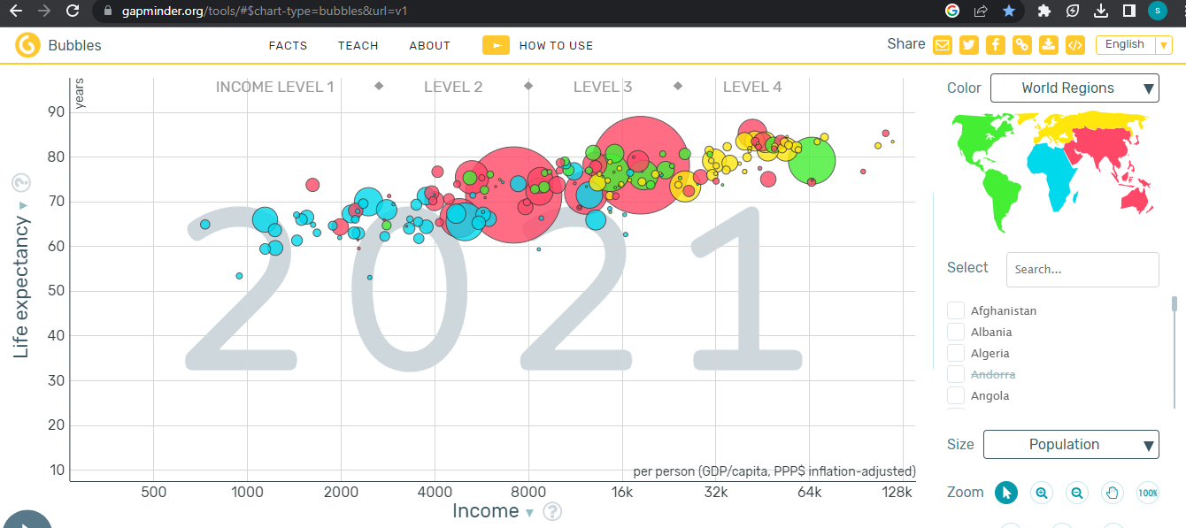
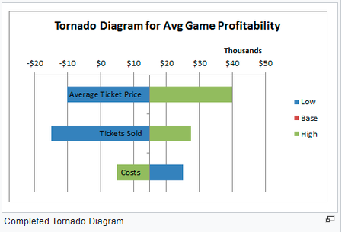
Shouldn’t each variable have the same starting point . I’m not sure how this is considered a tornado chart. I could be I haven’t been exposed to many tornado charts. I would like to see them overlapping or both having th same starting point in opposite direction.
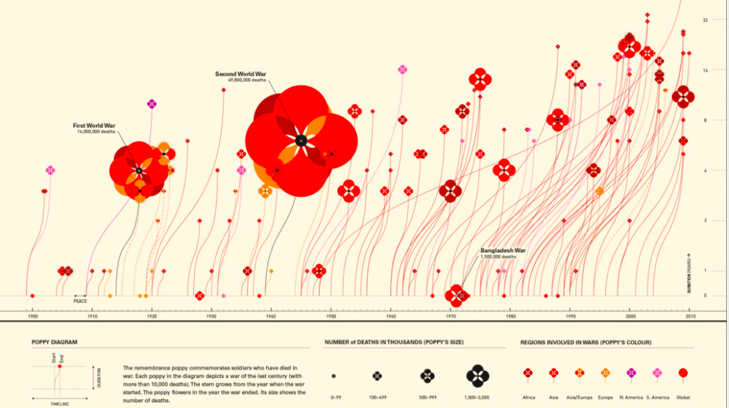
I was only able to find the image of this chart. Was looking for the interactive version. So I have to go off just looking at it. Every flower is a war but what war is it. The size of the flower is how many lives were lost, but you can’t differentiate the casualties from the countries. Like in world war II I’m guessing Asia had way more casualties then Europe, the key only shows that the size of the flower represents the deaths. I only see peace on the time once but it looks like it could have been on there at least two other times. At first glance I thought the length of the flowers stem represented the duration of the war. This isn’t the case its where the flower has blown to on the chart.

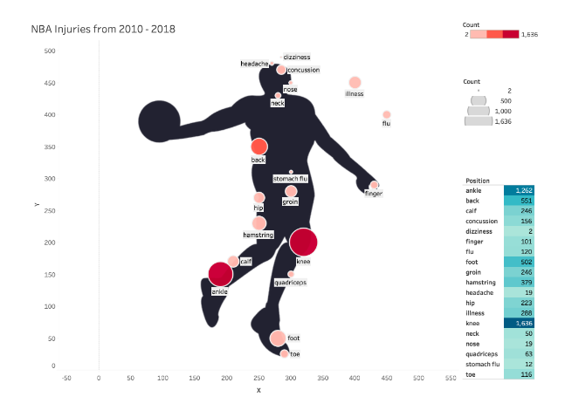
I Have no idea what x,y represents. There are only three colors and the chart goes from 2-1636 wow that’s a super gap. There are two (count) keys one that is color coded and the other gap coded. I have no idea what the gap count is. The only definite data on here I see. Is this is a depiction of injuries in the NBA from 2010-2018, and the amount of injuries that happened in that time. The key in the blue shows you the amounts of injuries but you really don’t get that looking at the visual

